Type here the title of the submission

First name Surname¹, First name Surname², First name Surname³

¹ Enter author affiliation and address, (author1@email.com)
² Enter author affiliation and address, (author2@email.com)
³ Enter author affiliation and address, (author3@email.com)

Key words: keyword1; keyword2; keyword3; keyword4; keyword5

ABSTRACT
This template is provided for the preparation of the papers (oral and poster) accepted for publication in the proceedings of the 5th Joint International Symposium on Deformation Monitoring. These guidelines are issued to ensure a uniform style for all papers. Abstract length should be between 100 and 250 words. Reproduction of this template is made directly from author-prepared manuscripts, in electronic or hardcopy form, in A4 paper size 297 mm x 210 mm (11.69 x 8.27 inches). Authors must submit their manuscripts in strict conformance with these guidelines.

Manuscript

General Instructions
The paper length must be between 6 to 8 pages. Papers submitted for the 4th JISDM should have the following structure:
- title of the paper
- authors and affiliation
- keywords (6-8 words)
- abstract (100 – 250 words)
- introduction
- main body
- conclusions
- acknowledgements (if applicable)
- references
- appendix (if applicable)

A full paper is required for every accepted abstract, either oral or poster. Authors can submit their contribution as a peer review or non-peer review paper.
When preparing your paper please use this template. Papers submitted with incorrect formatting will be returned to authors.

Table 1. Example table
Column 1 | Column 2
 | Value 1 | Value 2
Cell 1 | 25 | 1.0
Cell 2 | 25 | 1.0
Cell 3 | 20 | 0.8

Page Layout, Spacing and Margins
The paper must be compiled in one column for the Title, Abstract and keywords and in two columns for all subsequent text. All text should be single-spaced, unless otherwise stated. Left and right typing must be justified. Left and right page margins must be 2.30 cm and top and bottom margins 2.25 cm and 2.00 cm accordingly.

Length and Font
All manuscripts, are limited to a size between six (6) to eight (8) single-spaced pages (A4 size), including abstracts, figures, tables and references. The font type Calibri with a size of ten (10) points is to be used.

Title and abstract block

Title
The title should appear centered in bold capital letters, at the top of the first page of the paper with a size of fourteen (14) points and single-spacing. After one blank line, type the author(s) name(s) in upper and lower-case letters, centered under the title. Affiliation and mailing address (including e-mail) must follow justified left. In the case of multi-authorship, group them by organization or firm as shown in the title of these Guidelines.

Key Words
Leave one line blank, then type " Key words: " in bold letters, followed by 5-8 key words. Include those key words which you would use to find a paper with the content you are preparing.

Abstract
Leave two blank lines under the key words. Type "ABSTRACT" flush left in bold Capitals. Start now with a concise abstract (100 - 250 words) which contains a brief summary of your work including scope, content and key results of your research.

Main body of text
Type text in the main body of your paper single-spaced, without introducing a blank line between paragraphs. Prior to every new section introduce a blank line as in this template.

Headings
Major headings are to be centered, in small caps without underlining.
Type subheadings flush with the left margin in upper-case and lower case-letters. Subheadings are on a separate line after one blank line.

Footnotes
Use footnotes only if necessary. In case a footnote is used mark it in the text with a number. Footnote numbering starts from one for every page. Place footnotes at the bottom of the page, separated from the text above it by a horizontal line.

Illustrations and Tables

Placement: Figures must be placed in the appropriate location in the document, as close as practically possible to the reference of the figure in the text. Avoid placing figures occupying the full page width (two-columns). If necessary place them at the top or bottom of a page.

Captions: Captions should be typed in upper and lower-case letters, centred directly beneath the object for figures and directly above for tables. Use single spacing for inserting caption text. All captions are to be numbered consecutively for figures and tables accordingly.

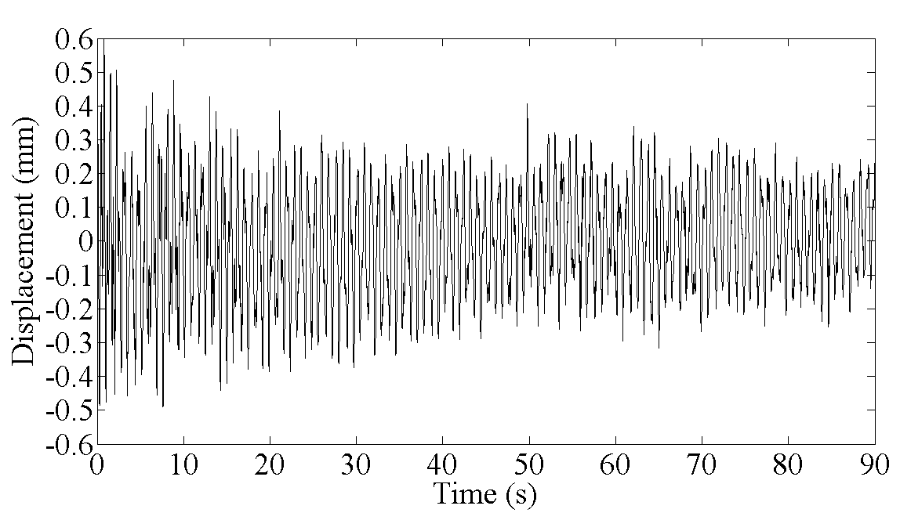
Figure 1. Figure placement and numbering

Equations, Symbols and Units
Equations should be numbered consecutively throughout the paper. The equation number is enclosed in parentheses and placed flush right. Leave one blank line before and after equations:

${\hat{d}}_{ij}=d_{ij}+f_{P}\left(d_{ij}\right)$ (1)

where ${\hat{d}}_{ij}$ = compensated distance from i to j
$d_{ij}$ = raw distance from i to j
$f_{P}$ = polynomial as a function of $d_{ij}$

Use the SI (Système Internationale) Units and Symbols throughout your paper. Unusual characters or symbols should be used only if necessary and explained in a list of nomenclature.

References
References should be cited within the text as (Smith, 2017a; Wilson et al., 2007) and listed in alphabetical order in the reference section.

Acknowledgements (optional)
Acknowledgements of support for the project/paper/author are welcome.

References
Bastos, L., S. Cunha, R. Forsberg, A. Olesen, A. Gidskehaug, U. Meyer, T. Boebel, L. Timmen, G. Xu, M. Nesemann, K. Hehl (1998). An Airborne Geoid Mapping System for Regional Sea-Surface Topography: Application to the Skagerrak and Azores Areas. In: Proc of International Association of Geodesy Symposia ‘Geodesy on the Move’. Forsberg R Feissel M Dietrich R (eds) Vol. 119, Springer Berlin Heidelberg NewYork, pp 30-36.
Brozena, J.M. (1992). The Greenland Aerogeophysics Project: Airborne Gravity, Topographic and Magnetic Mapping of an Entire Continent. In: Proc. Of IAG Symposium G3: Determination of the Gravity Field by Space and Airborne Methods, Springer Verlag, pp. 203-214.
Bruton, A.M., C. Glennie, and K.P. Schwarz (1999). Differentiation for High Precision GPS Velocity and Acceleration Determination. GPS Solutions, Vol 2, No. 4.
Foote, S.A., and D.B. Grindeland (1992). Model QA-3000 Q-Flex Accelerometer: High Performance Test Results. In: Proc. Of IEEE PLANS 92, IEEE, Piscataway, NJ, pp. 534-543.
Forsberg, R., A.V. Olesen, and K. Keller (1999). Airborne Gravity Survey of the North Greenland Shelf 1998. Kort & Matrikelstyrelsen Technical Report, in print.

Appendix (optional)
Any additional supporting data may be appended, provided the paper does not exceed the limits given above.

Place the footnote here

